**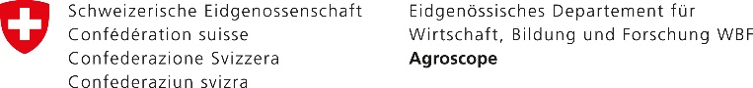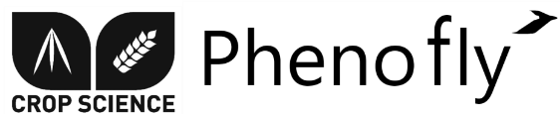

**Flower mapping in grasslands with drones and deep learning**

*Master Thesis Outline for Johannes Gallmann*

The framework of the thesis is the project FRAGMENT, a collaboration of Agroscope Reckenholz, WSL Birmensdorf and the University of Landau (DE), which aims to predict ecosystem service provision by pollinators and pest control agents from environmental traits. The service done by pollinators in Swiss farmland is estimated to value more than 150 Billion Euros a year. Their declining numbers motivate many ecologists to study their interplay with the environment. This often includes the assessment of flower abundance and distribution, which is an extremely time consuming task.

In the last 10 years, development in robotics, computer vision, and sensor technology has provided new remote sensing tools to capture unprecedented ultra-high spatial and high temporal resolution with unmanned aerial vehicles (UAVs). Additionally, deep learning based classification methods have appeared that are able to utilize the details of that data.

The main goal of the thesis is to develop software that is able to detect and classify flowers in drone images of grasslands. The thesis can be grouped into three work packages as described below:

**Work package 1:** Development of labelling tool for Android tablets

The labelling tool is used to annotate all flowering plants in drone images with the corresponding name. These annotations are later used as training data input for the deep learning models. The labelling tool is meant to be used in the field such that flowers not being conclusive from the image alone can be found in the field to verify the species. The displayed images are compound of multiple subimages merged together by the Agisoft software.

Requirements:

* Displaying georeferenced, zoomable Images
* Displaying user’s position on top of Image and automatic adjustment of Image position
* Annotation of flowering plants with bounding polygon or centering point
* Easily editable and exchangeable List of plant species
* Reliable, i.e. back up annotation work continuously

**Work package 2:** Implementation of Tensorflow model and Prediction tool

An appropriate Tensorflow model has to be found and tuned for reliable Flower classification. Work package 2 can be divided into three subtasks.

Subtasks:

1. get reliable predictions from the model
2. Output of prediction data (visualizations)
3. the tool should be user friendly such that it can be used for further predictions or trainings with new images by non-developers

**Work package 3:** Analysis and Documentation

Different configurations should be analyzed.

Subtasks:

* Analysis of effect of decreasing image resolution
* Analysis of different sizes of the bounding boxes
* Writing Documentation
* Writing Thesis

Parts of work package 3 can already be relevant during the work of work package 2.